MINI PROJECT

Name : SURYA PRAKASH A
Reg No : 411625149051
Department :CYBER
Subject :PYTHON
Batch :4

Mini Project:
Number Guessing Game using Python (Loop Based)

1. Project Title
Number Guessing Game using Python using Loop Concept

2. Problem Statement
To develop a loop-based number guessing game where the user repeatedly guesses a number until the correct number is found.

3. Objective
- To understand while loop concept in Python
- To apply conditional statements inside loops
- To demonstrate repeated execution using loops

4. Tools Used
- Python 3
- VS Code / IDLE

5. Description
This project is a simple number guessing game.
The program generates a fixed number and allows the user to guess the number repeatedly using a while loop until the correct guess is made.

6. Algorithm
- Start the program
- Set a fixed secret number
- Ask the user to enter a guess
- Compare the guess with secret number
- If guess is wrong, repeat using loop
- If guess is correct, display success message
- Continue loop until correct guess
- End the program

7. Program (Python Code)
secret_number = 7
guess = 0

while guess != secret_number:
guess = int(input("Enter your guess: "))

if guess < secret_number:
print("Too low! Try again.")

elif guess > secret_number:
print("Too high! Try again.")

else:
print("Congratulations! You guessed the correct number.")

8. Sample Output
Enter your guess: 3
Too low! Try again.
Enter your guess: 9
Too high! Try again.
Enter your guess: 7
Congratulations! You guessed the correct number.

Coding:
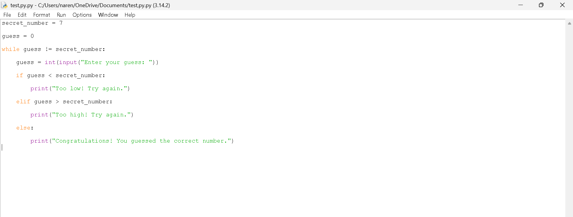

Output:
